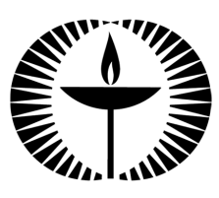
Touchstones
Netcards

Forgiveness Netcards with Text

Angels HRJ
Anger HRJ
Begin HRJ
Better Past HRJ

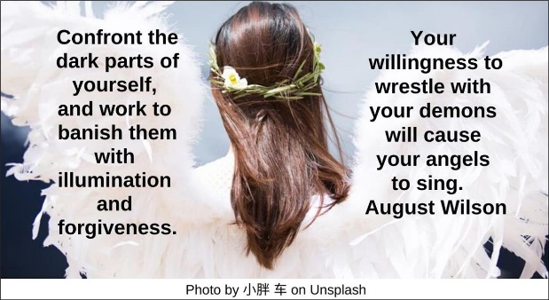

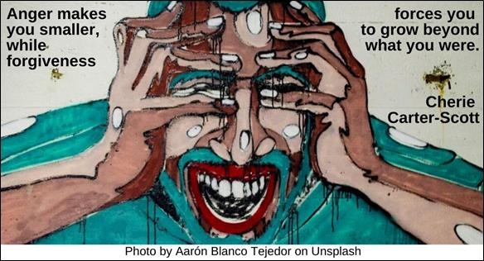

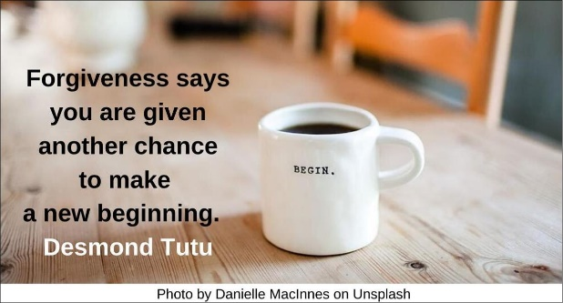

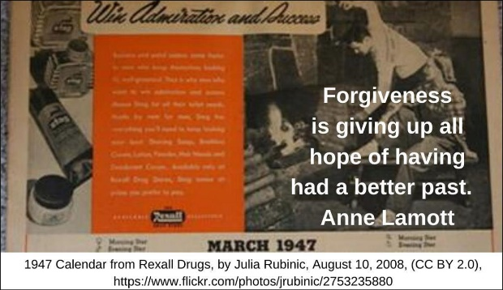
Broken Bridge HRJ
Broken HRJ
Deserve Peace HRJ
Drum Practice HRJ

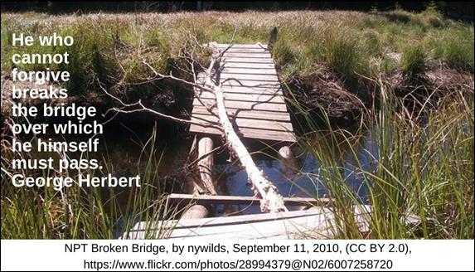

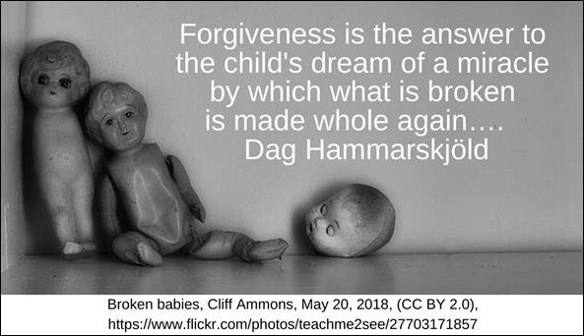

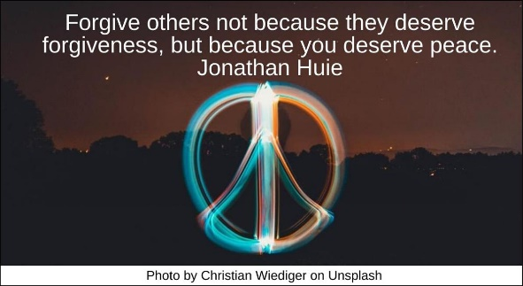

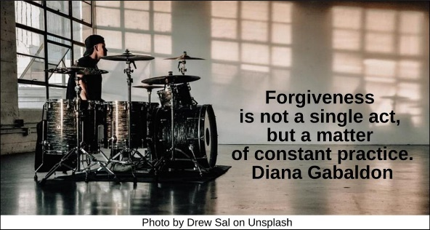

Enemy HRJ
Forgive Me HRJ
Free HRJ
Free Rent HRJ

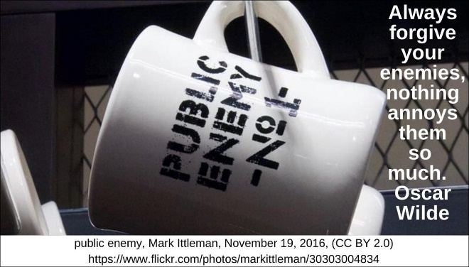

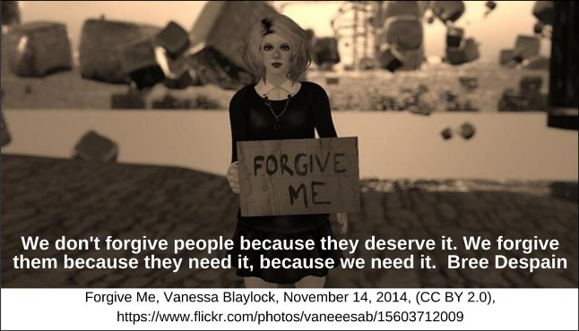

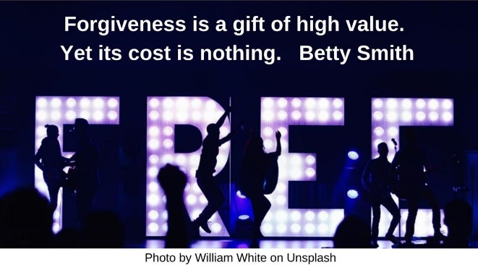

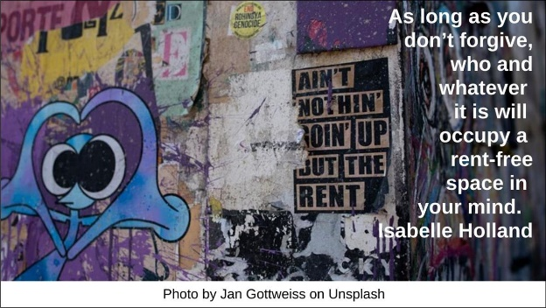

Future HRJ
Gift HRJ
Healing HRJ
Heart HRJ



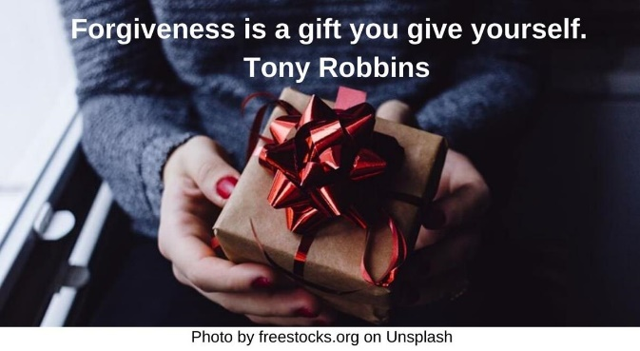

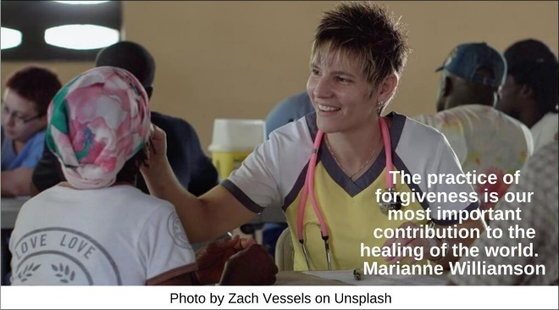

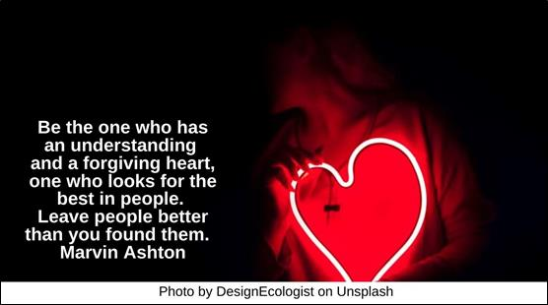

Human HRJ
Infinite Possibility HRJ
Life HRJ
Locked Door HRJ

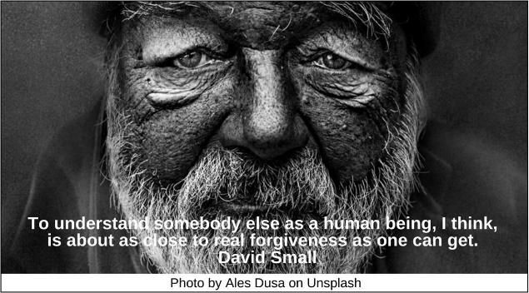

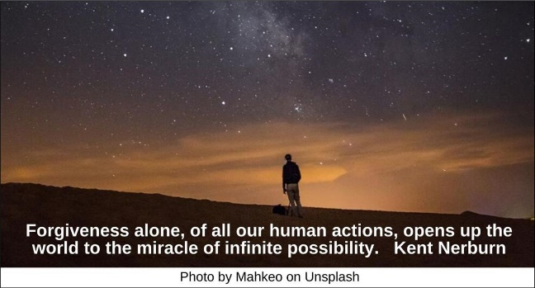

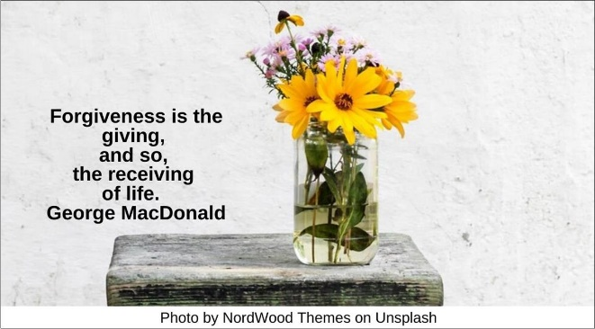

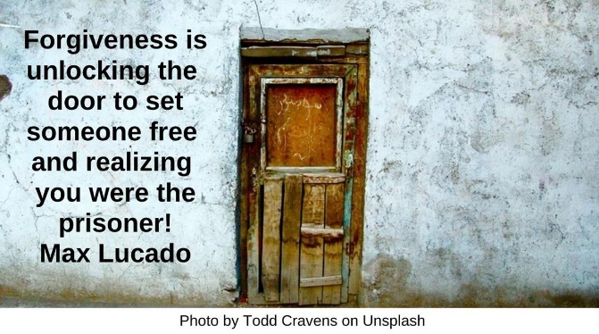

Love HRJ
Love One Another HRJ
Maturity HRJ
Old Tree HRJ

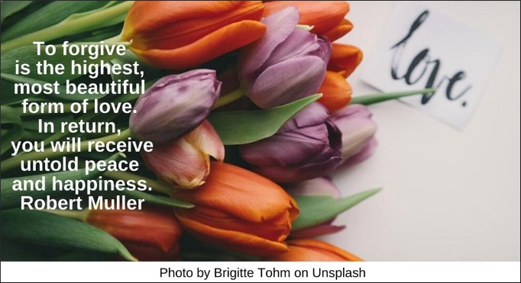

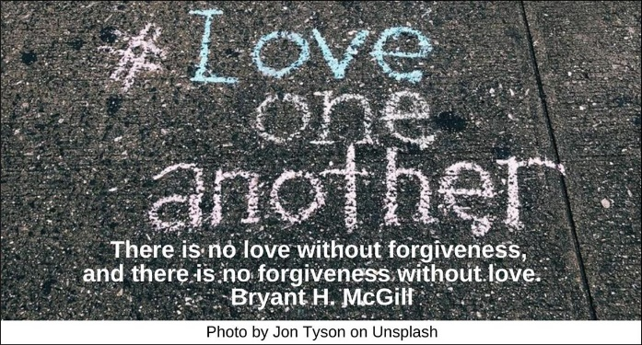

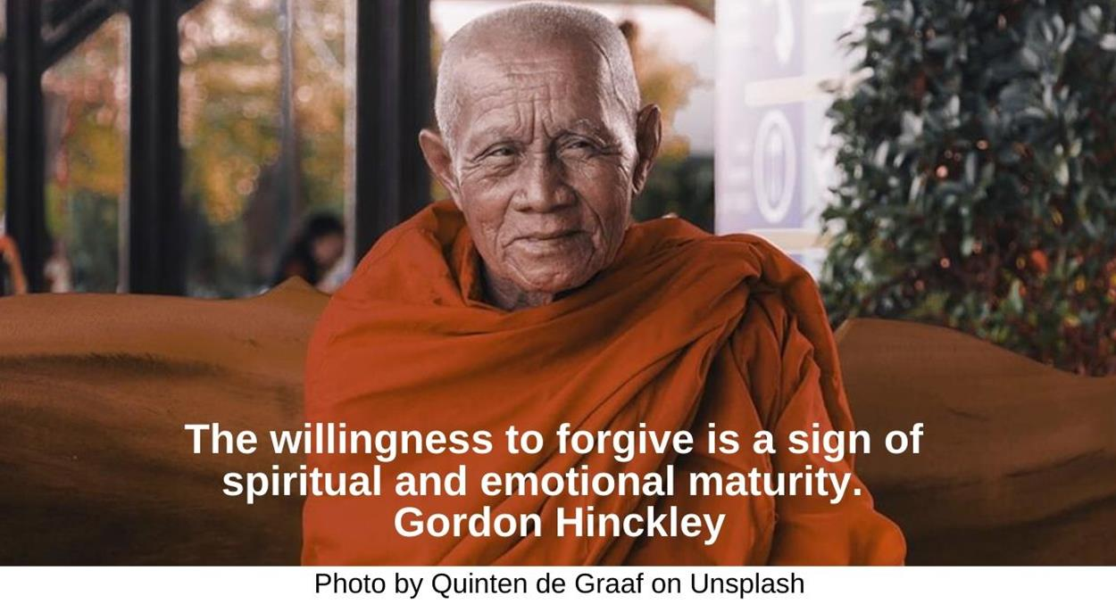

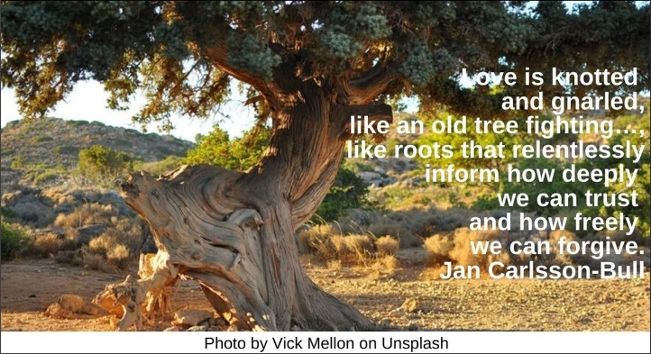

Orchid HRJ
Peace HRJ
Powerful Place HRJ
Rat HRJ

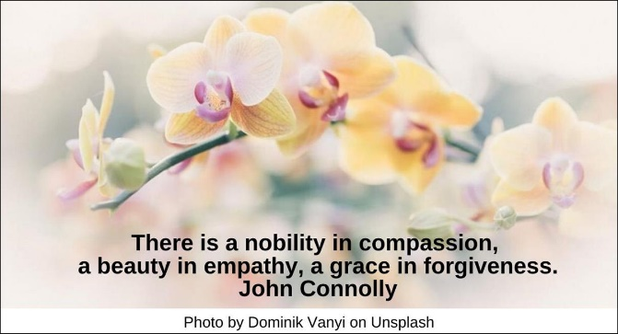

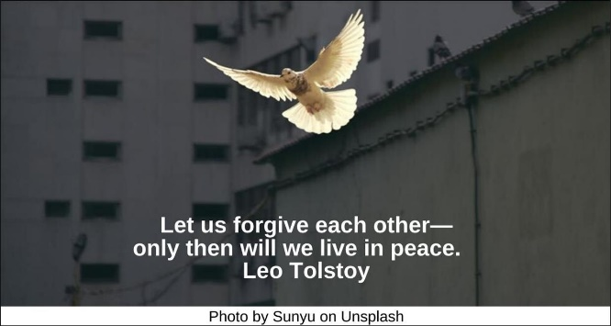

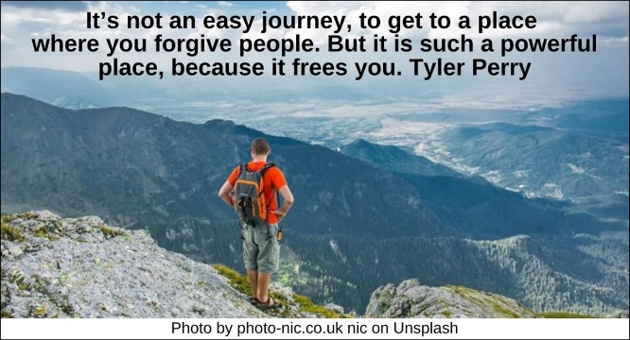

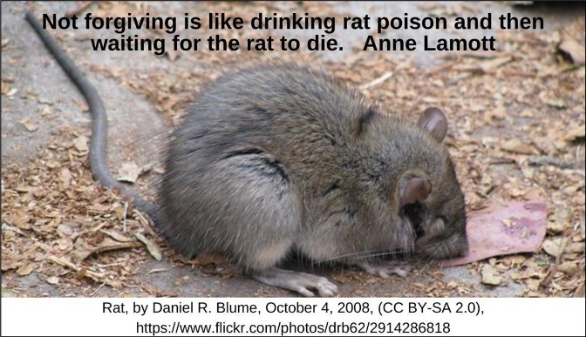

Resentment HRJ
Rise Above HRJ
Sew HRJ
Understanding HRJ
World Religions HRJ

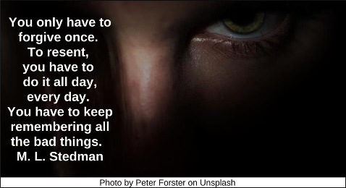

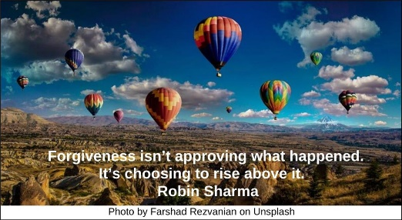

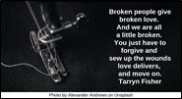

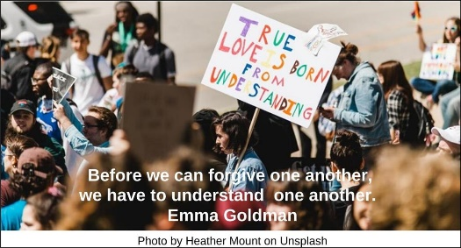

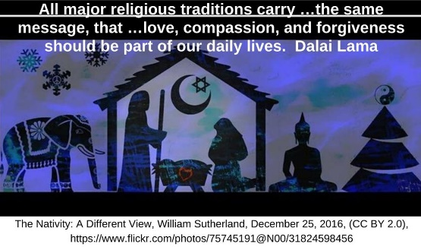

Text of Quotes

Angels
Confront the dark parts of yourself, and work to banish them with illumination and forgiveness. Your willingness to wrestle with your demons will cause your angels to sing. August Wilson

Anger
Anger makes you smaller, while forgiveness forces you to grow beyond what you were. Cherie Carter-Scott

Begin
Forgiveness says you are given another chance to make a new beginning.
Desmond Tutu

Better Past
Forgiveness is giving up all hope of having had a better past. Anne Lamott

Bridge
He who cannot forgive breaks the bridge over which he himself must pass.
George Herbert

Broken
Forgiveness is the answer to the child's dream of a miracle by which what is broken is made whole again….
Dag Hammarskjöld

Deserve Peace
Forgive others not because they deserve forgiveness, but because you deserve peace. Jonathan Huie

Drum Practice
Forgiveness is not a single act, but a matter of constant practice. Diana Gabaldon

Enemy
Always forgive your enemies—nothing annoys them so much. Oscar Wilde
Forgive Me
We don't forgive people because they deserve it. We forgive them because they need it—because we need it. Bree Despain

Free
Forgiveness is a gift of high value. Yet its cost is nothing. Betty Smith

Free Rent
As long as you don’t forgive, who and whatever it is will occupy a rent-free space in your mind. Isabelle Holland

Future
When you forgive, you in no way change the past, but you sure do change the future. Bernard Meltzer

Gift
Forgiveness is a gift you give yourself. Tony Robbins

Healing
The practice of forgiveness is our most important contribution to the healing of the world. Marianne Williamson

Heart
Be the one who has an understanding and a forgiving heart, one who looks for the best in people. Leave people better than you found them. Marvin Ashton

Human
To understand somebody else as a human being, I think,
is about as close to real forgiveness as one can get. David Small

Infinite Possibility
Forgiveness alone, of all our human actions, opens up the world to the miracle of infinite possibility. Kent Nerburn

Life
Forgiveness is the giving, and so, the receiving of life. George MacDonald

Locked Door
Forgiveness is unlocking the door to set someone free and realizing you were the prisoner! Max Lucado

Love
To forgive is the highest, most beautiful form of love. In return, you will receive untold peace and happiness. Robert Muller

Love One Another
There is no love without forgiveness, and there is no forgiveness without love. Bryant H. McGill

Maturity
The willingness to forgive is a sign of spiritual and emotional maturity.
Gordon Hinckley

Old Tree
Love is knotted and gnarled, like an old tree fighting…, like roots that relentlessly inform how deeply we can trust and how freely we can forgive. Jan Carlsson-Bull

Orchid
There is a nobility in compassion, a beauty in empathy, a grace in forgiveness.
John Connolly

Peace
Let us forgive each other—only then will we live in peace. Leo Tolstoy

Powerful Place
It’s not an easy journey, to get to a place where you forgive people. But it is such a powerful place, because it frees you.
Tyler Perry

Rat
Not forgiving is like drinking rat poison and then waiting for the rat to die. Anne Lamott

Resentment
You only have to forgive once. To resent, you have to do it all day, every day. You have to keep remembering all the bad things. M. L. Stedman

Rise Above
Forgiveness isn’t approving what happened. It’s choosing to rise above it.
Robin Sharma

Sew
Broken people give broken love. And we are all a little broken. You just have to forgive and sew up the wounds love delivers, and move on. Tarryn Fisher

Understanding
Before we can forgive one another, we have to understand one another. Emma Goldman

World Religions
All major religious traditions carry …the same message, that …love, compassion, and forgiveness should be part of our daily lives. Dalai Lama

